Duct Tape Safaris
South Sudan’s newest tourist agency held by sticky tape and a dream
PITCH BIBLE
The First Animated Series Set in South Sudan
22-Minute Episodes | Ages 8-14
Educational Comedy • Adventure • Heart

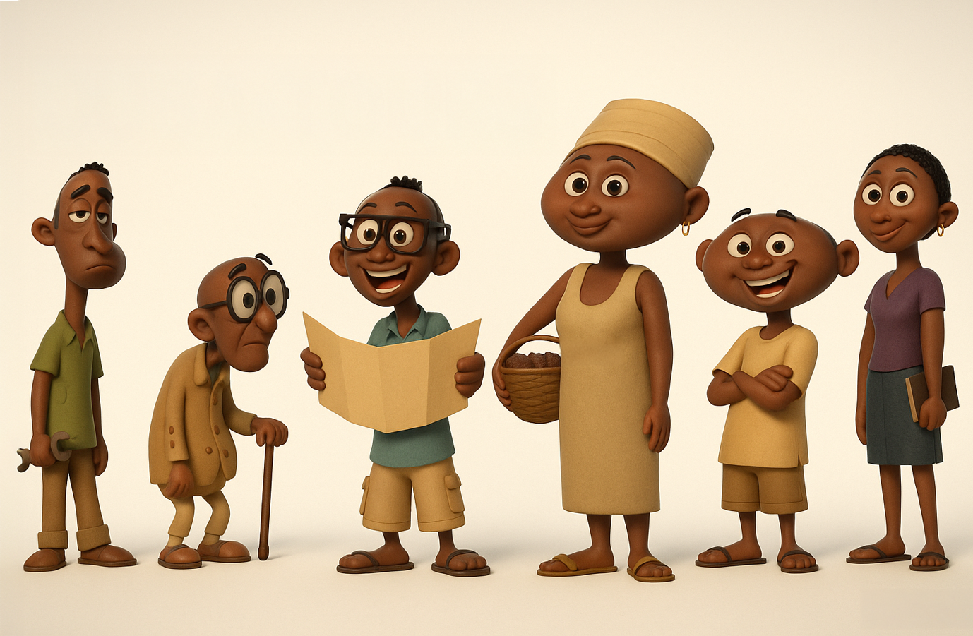

THE BIG IDEA
Two unemployed young friends in South Sudan have nothing—except a dream, a worn-out minibus, and the breathtaking beauty of their country. Against all odds, they're fighting their way out of poverty, one chaotic tour at a time.

SERIES LOGLINE
Two unemployed young friends in South Sudan start a ramshackle tour business with a worn-out minibus to elevate themselves out of poverty. They have nothing—but a strong desire to succeed against all odds. By leveraging the hidden beauty of South Sudan, they transform struggle into hope, teaching viewers about resilience, geography, and the power of determination.

THE HOOK
A story of hope, hustle, and heart from Africa's youngest nation
- FIRST animated series set entirely in South Sudan
- Real stakes: Fighting poverty with creativity and determination
- Authentic representation by creators who know the culture
- Educational content woven into laugh-out-loud comedy
- Untapped setting with incredible visual potential
- Universal themes: Entrepreneurship, resilience, starting with nothing
- Built-in curriculum alignment for educational broadcasters

WHY NOW?
- Stories of resilience resonate globally—especially post-pandemic
- Growing global demand for authentic African stories
- South Sudan (independent since 2011) is hungry for original content
- Educational entertainment is proven, fundable format
- Youth audiences want stories that reflect real-world challenges
- Positive representation counters negative news narratives

THE TONE
Think Bob's Burgers (resourceful family fighting to make it) meets The Wild Thornberrys (geography education through adventure) in South Sudan. Warm family comedy with genuine heart, grounded in real economic challenges, celebrating hustle, hope, and the determination to succeed against the odds.

MEET THE CHARACTERS
Every great adventure needs a
memorable crew fighting for their dreams.
[CHARACTER DESIGN]  MAWAN  Age 25 • The Dreamer  Charismatic salesman with more enthusiasm than sense. Sees opportunity everywhere—even when there isn't any. His genuine passion and refusal to give up keeps the business alive, even when his impulsive decisions threaten to sink it. | [CHARACTER DESIGN]  TOBI  Age 23 • The Brain  Methodical planner who knows more about South Sudan's geography than anyone should. The voice of reason who constantly saves the business from Mawan's wild schemes. Smart, practical, but secretly just as desperate to make this work.
[CHARACTER DESIGN]  AKECH  Age 19 • The Voice  Sharp-tongued university student representing aspirational South Sudanese youth. Socially aware, always connected, teases her brothers mercilessly while secretly rooting for them. Brings social media savvy to the struggling business. | [CHARACTER DESIGN]  DENG  Age 28 • The Wild Card  Supremely lazy mechanic who owns the minibus. Prefers sleeping under it to fixing it. His laziness creates comedic chaos, but when motivated (usually by money or food), he's surprisingly brilliant—proving even the least likely people have hidden talents.
SUPPORTING CAST:
- NYANDENG (50s) — The practical mother, skeptical but secretly proud
- GRANDFATHER (70s) — Storyteller with questionable memory, living history
- AYEN (mid-20s) — Skilled pilot (joins Episode 6), brings aerial perspective and female empowerment

STANDOUT EPISODES
Each 22-minute episode delivers laughs, heart, authentic education, and the underlying tension of characters fighting to survive.
EPISODE 1: "THE BIG IDEA" (PILOT)
The Setup: Unemployed and broke, Mawan and Tobi hear a safari commercial on the radio and have a wild idea: start their own tourism business. They convince lazy mechanic Deng to lend them his worn-out minibus. Their first customer—a skeptical British businessman—gets more than he bargained for when a hippo encounter at a local national park turns terrifying…then thrilling. They earn their first pay and realize this crazy idea might actually work.
Educational Focus: White Nile geography, hippo dangers, introduction to Sudd wetlands, South Sudan's size (larger than France), independence (2011)
Why It Works: Establishes the desperate stakes (poverty, unemployment) while delivering hope and humor. Proves the formula: chaos + heart + learning = compelling television.
EPISODE 2: "GOING VIRAL"
The Setup: Instagram influencer “Maya” books a tour expecting luxury. Instead, she gets soaked by an elephant, licked by a giraffe, and stranded when the minibus breaks down at golden hour in Bandingilo National Park. Akech helps Maya discover that authentic, messy experiences make better content than perfection. Maya's honest post about the 'disaster' goes viral—bringing their first real wave of customers.
Educational Focus: Bandingilo National Park, second-largest wildlife migration in Africa (1+ million antelope), white-eared kob, elephant behavior
Why It Works: Hilarious visual comedy paired with genuine message about authenticity. Shows how the business grows through word-of-mouth and proves that their 'failures' can become their greatest assets.
EPISODE 5: “The SHOEBILL”
The Setup: When an enthusiastic American birdwatcher offers a large payment to photograph the elusive shoebill stork, Mawan eagerly accepts the job without realizing the birds live deep inside the Sudd wetlands. With roads impassable and time running out, the team searches for an affordable flight and discovers Ayen, a young pilot running a tiny charter operation with a worn (but functional) plane. Despite doubts about the aircraft and a nerve-rattling, turbulent first flight for Mawan, Ayen’s careful safety checks and steady piloting get them safely into the wetlands. Guided by a local ranger, the group travels by boat through papyrus channels and witnesses multiple shoebills in their natural habitat, giving the tourist the experience of a lifetime—and securing a new partnership for future journeys.
Educational Focus: The Sudd wetlands; shoebill storks; ecosystems and conservation

EPISODE 6: "LOST IN TRANSLATION"
The Setup: This is a warm, funny, and sometimes nerve-wracking adventure that follows a Chinese businessman (with his family) is on a business trip in Juba. Communication is a translation app that seems determined to cause chaos. The app cheerfully turns “hippopotamus” into “river horse” and scrambles safety warnings into nonsense - leaving Mawan and Tobi desperately trying to explain how dangerous the animals really are—through gestures and increasingly frantic miming.
Meanwhile, Lily, the teenage daughter glued to her cell phone and translating as best she can, becomes the crucial bridge between cultures. As phones die and words fail, a day full of comic misunderstandings transforms into awe and respect along the White Nile. By the time a very real hippo asserts its presence, confusion gives way to understanding, laughter to shared wonder, and strangers to friends—proving that even when language fails, kindness and curiosity speak every language.
EPISODE 7: "DINKA DINKA DO"
The Setup: When Mawan and Tobi plan a cultural tour to a traditional Dinka cattle camp, Mawan’s mother, Nyandeng, insists on joining—pointing out that “city Dinka” won’t be enough. On the long drive from Juba to Lakes State, Nyandeng becomes the group’s guide, teacher, and cultural bridge. At the cattle camp, her language, family ties, and deep knowledge transform a cautious welcome into a warm embrace. As the tourists learn about cattle traditions, songs, and daily life—and hilariously attempt cattle dances themselves—Mawan realizes that the tour’s success depends not on his plans, but on respect, preparation, and listening to those who know best. The episode becomes a deep dive into living heritage—and the boys gain newfound respect for their mother's roots.
Educational Focus: Dinka culture (largest ethnic group), cattle as central to identity (wealth/status/spirituality), bride wealth traditions, cattle naming, songs and poetry
Why It Works: Emotional depth and cultural authenticity. Shows that heritage and tradition are treasures worth sharing—and that understanding your roots strengthens you for the future.
EPISODE 13: "RETURN OF THE LIONS" (SEASON FINALE)
The Setup: For their most ambitious tour yet, Mawan books an overnight camping experience where lions have recently returned after decades of absence. What should be their triumphant season finale turns tense when lions approach the camp at night. The team must keep tourists safe while respecting wildlife. Everyone's skills combine—Tobi's knowledge, Ayen's aerial scouting, Deng's unexpected bravery, Grandfather's old techniques—proving they've become a real team. They've come so far from that first chaotic hippo encounter.
Educational Focus: Lion conservation, ecosystem balance, human-wildlife coexistence, apex predators' importance, nighttime safety
Why It Works: Perfect season finale with highest stakes. All character arcs pay off. The team has evolved from broke dreamers into a legitimate business with skills, reputation, and genuine impact on their community. The fight against poverty continues—but now they have hope, experience, and each other.

AUDIENCE & MARKET

PRIMARY AUDIENCE
Ages 8-14 (Core: 9-12)
- Kids who love adventure, comedy, and rooting for underdogs
- Globally curious children seeking authentic cultural experiences
- Young viewers inspired by stories of determination and resourcefulness
- Families watching together (strong co-viewing appeal)

SECONDARY AUDIENCES
- South Sudanese and East African youth (ages 10-25)
- International audiences interested in African stories
- Educators seeking geography and cultural literacy content
- Young entrepreneurs and aspiring business owners
- Travel and wildlife documentary enthusiasts

COMPARABLE SHOWS
Show | What We Share
Bob's  Burgers | Entrepreneurial family, warm humor, financial struggles
Wild Thornberrys | Geography education through adventure, wildlife  exploration
Carmen Sandiego | World geography, cultural education, clever problem-solving
Bluey | Authentic cultural representation, universal family themes
BUT WHAT MAKES US UNIQUE:
- First series set in world's youngest country
- Real stakes: characters fighting poverty, not just having fun
- Authentic voices telling their own stories
- Untapped visual landscape (second-largest wildlife migration!)

EDUCATIONAL BROADCASTER POSITIONING
DUCT TAPE SAFARIS
EDUCATIONAL FOCUS  Each episode naturally incorporates:  - Geography of South Sudan  - Environmental awareness  - Cultural traditions & languages  - Entrepreneurship & problem-solving  - Social cooperation & empathy | CURRICULUM ALIGNMENT  Supports learning objectives in:  - Geography  - Social studies  - Cultural literacy  - Character education  - Life skills & financial literacy
WHY THIS SERIES IS VALUABLE:
- Provides rare youth-centered storytelling set in South Sudan
- Counters simplistic or negative stereotypes with humor and humanity
- Encourages global curiosity, cultural literacy, and empathy
- Aligns with public and educational broadcaster mandates for diversity and learning
BROADCASTER FIT:
- Educational streaming platforms
- International youth programming blocks
- Classroom licensing (built-in teacher guides)
Shows like Carmen Sandiego and Wild Thornberrys prove that geography education + entertainment = ratings gold. “Yalla, Yalla!” brings this proven formula to an untapped setting with higher emotional stakes.

MERCHANDISING & REVENUE STREAMS

MERCHANDISING LANGUAGE
APPROVED SLOGANS:
- START BROKE. GO FAR.
- BIG DREAMS. SMALL STARTS.
- KEEP GOING.
MERCHANDISING GUIDELINES:
- Positive, encouraging language
- School-appropriate and globally suitable
- Rounded fonts and bright, friendly colors
- No violent, fear-based, or exclusionary imagery

MULTIPLE REVENUE STREAMS
Revenue Stream | Opportunity
Broadcast Rights | Primary revenue from broadcasters
Streaming Licensing | Educational platforms, international markets
Educational Licensing | Schools, curriculum packages, teacher guides
Merchandising | Apparel, toys, books, educational materials
Tourism Partnerships | South Sudan tourism board, conservation orgs

THE OPPORTUNITY
Be part of groundbreaking storytelling that educates, entertains, and inspires—while filling a massive gap in global representation.

WHAT WE'RE SEEKING
- Broadcasting partners committed to diverse, educational content
- Production funding for Season 1 (13 episodes)
- Distribution partners for international markets
- Educational co-production opportunities

WHY INVEST NOW
✓ MARKET DEMAND  Broadcasters seeking diverse content  Proven appetite for educational entertainment  Post-pandemic focus on resilience stories | ✓ TIMING  South Sudan's story ready to be told  Growing African animation industry  First-to-market advantage
✓ PROVEN FORMAT  Comparable shows are ratings successes  Educational + comedy = proven formula  Scalable, sustainable production model | ✓ IMPACT  Creates positive representation  Inspires youth entrepreneurship  Preserves cultural heritage

LET'S START THIS JOURNEY
"Every great adventure begins with someone brave enough to believe it's possible—even when starting with nothing."
Duct Tape Safaris isn't just a cartoon—it's proof that determination, creativity, and heart can overcome any obstacle. It shows the world that South Sudan has stories worth telling, landscapes worth exploring, and young people worth celebrating. Most importantly, it proves that where you start doesn't determine how far you go.
Join us in bringing this groundbreaking series to life.
Duct Tape Safaris
South Sudan’s newest tourist agency held by sticky tape and a dream

CONTACT
Carl Nestor
Ashland, Ohio
(419) 554-4487
carlnestor@me.com

